ADIDAS CAMPUS 00S SHOES
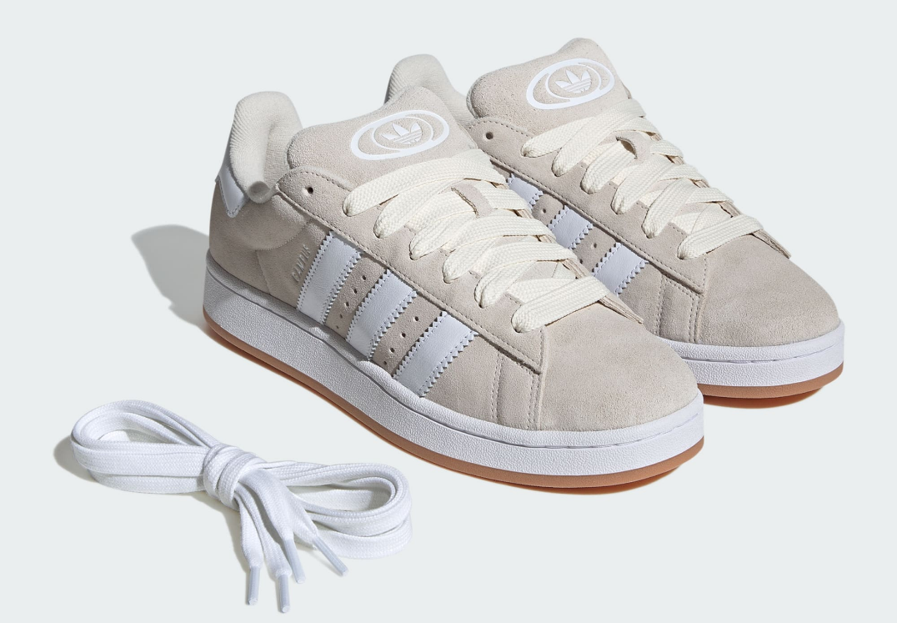
PRICE: Approximately Rs. 24,999

_{Introduction:}
The Adidas Campus 00S Shoes bring a bold revival of classic street style with a modern, oversized aesthetic inspired by early 2000s fashion. Designed for comfort, durability, and everyday wear, these sneakers blend iconic Adidas heritage with contemporary design elements. Featuring a chunky silhouette, premium materials, and cushioned support, the Campus 00S delivers both style and functionality. Whether you’re styling them for casual outfits, streetwear looks, or daily routines, these shoes offer a perfect balance of fashion and comfort, making them a standout choice for modern sneaker lovers.

Product Overview:
The Adidas Campus 00S Shoes feature a classic low-top design with a bold, updated silhouette. Built for lifestyle wear, they offer cushioned comfort, reliable traction, and premium finishing that makes them suitable for everyday use.
About the Brand:

is a world-renowned sportswear brand known for innovation, quality, and timeless design. With a strong legacy in both sports and streetwear culture, Adidas continues to create footwear that blends performance, style, and durability for global audiences.

Key Features:
- Iconic Campus design with modern 00s-inspired silhouette
- Cushioned midsole for everyday comfort
- Premium suede upper for a soft, stylish finish
- Durable rubber outsole for traction and stability
- Classic Adidas 3-Stripes branding
- Low-top profile for easy daily wear

Design & Build Quality:
The Adidas Campus 00S Shoes feature a chunky, bold design with high-quality stitching and reinforced overlays for durability. The premium suede upper adds a luxurious feel, while the structured shape maintains long-term form and visual appeal.
Storage & Capacity:
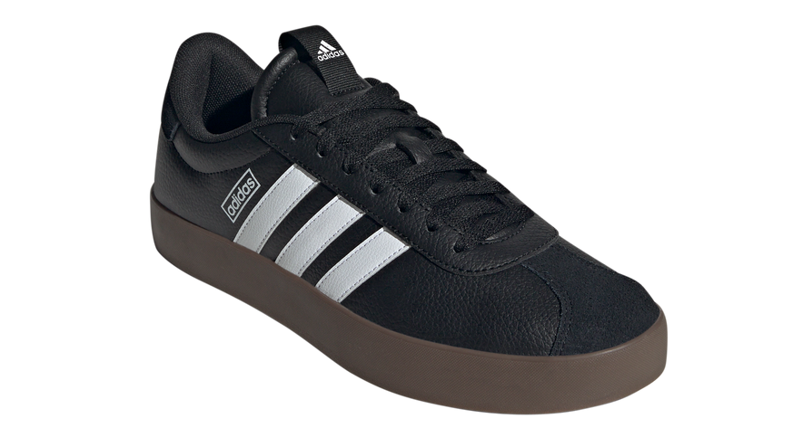
The shoes are designed to fit standard foot sizes comfortably, offering a secure lace-up closure for a stable fit. Their lightweight structure makes them easy to carry in travel bags or gym kits, suitable for daily use and travel.

Material & Durability:
Crafted from premium suede with a strong rubber outsole, the Adidas Campus 00S Shoes are built for long-lasting wear. The materials resist everyday abrasion while maintaining comfort and structural integrity over time.
Ideal For:
- Casual everyday wear
- Streetwear and lifestyle fashion
- College, travel, and daily routines
- Sneaker collectors and trend-focused users
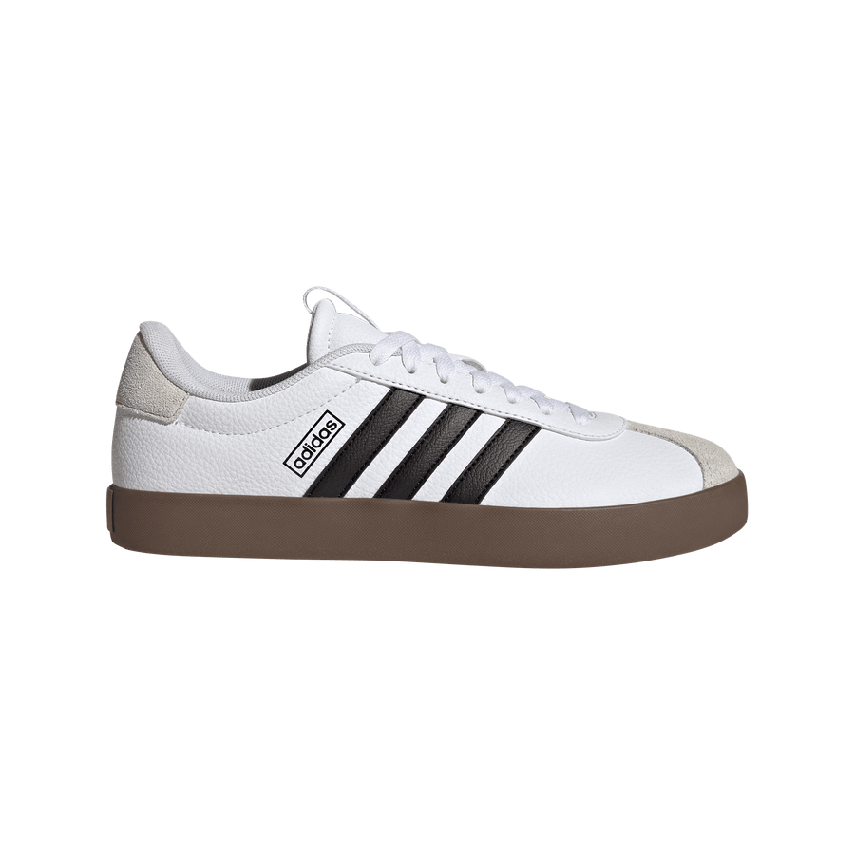

Care Instructions:
- Clean suede with a soft brush
- Avoid water exposure and machine washing
- Air dry away from direct heat
- Store in a cool, dry place
Product Specifications:
- Brand: Adidas
- Model: Campus 00S
- Product Type: Lifestyle Sneakers
- Upper Material: Suede
- Outsole: Rubber
- Closure: Lace-up
- Design Style: Chunky / 00s-inspired
- Sizes Available: UK 6–11 (approx.)

Product Summary:
The Adidas Campus 00S Shoes combine iconic heritage with modern streetwear style. With premium materials, bold design, and everyday comfort, they are a perfect choice for users who want fashion-forward sneakers with long-lasting quality.

